# Passive First order RC Filters

## Low pass filter

### Methodology

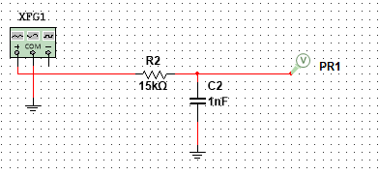

Figure shows a passive RC low pass filter. The values of the components were chosen because they match with circuit #1 of the D3000 board, “filters”.

### Results & Analysis

## High pass filter

### Methodology

### Results & Analysis

# Active Second order Sallen-Key filters

## Low pass filter

### Methodology

### Results & Analysis

## High pass filter

### Methodology

### Results & Analysis

## low pass filter with mid-band gain of 3

### Methodology

### Results & Analysis

# More complex filters

## Fourth order low pass Sallen-key filter

### Methodology

### Results & Analysis

## Second order band-pass Sallen-key filter

### Methodology

### Results & Analysis

## Second order band-reject Sallen-key filter

### Methodology

### Results & Analysis